**Department of Computer Science and Engineering**

**National Institute of Technology, Hamirpur**

**Name: Aryan Puri**

**Roll Number: 22BEC032**

**Digital Image Processing Lab (CS-325)**

**Solution Laboratory Assignment -2**

**Topic: Digital Image Histogram Equalization implementation and interpretation of results**

**Question: Design a program to read an image and apply histogram equalization. Show the input image and processed image with corresponding histograms. Write the conclusion based on the histogram equalization in terms of dynamic range, contrast, light, dark and dull images.**

**Solution:**

**Python Program:**

import cv2

import matplotlib.pyplot as plt

import numpy as np

imgInput=cv2.imread('./Assignment 2/image.png',0)

rows,cols=imgInput.shape

ihist=[0]*256

for i in range(rows):

    for j in range(cols):

        ihist[imgInput[i][j]]+=1

for i in range(256):

    ihist[i]/=(rows*cols)

trns=[0]*256

trns[0]=255*ihist[0]

for i in range(1,256):

    trns[i]=trns[i-1]+255*ihist[i]

imgOutput=np.zeros((rows,cols),dtype=np.uint8)

ohist=[0]*256

for i in range(rows):

    for j in range(cols):

        imgOutput[i][j]=round(trns[imgInput[i][j]])

        ohist[imgOutput[i][j]]+=1

for i in range(256):

    ohist[i]/=(rows*cols)

plt.plot(ihist)

plt.title('Histogram of Input Image')

plt.show()

plt.plot(ohist)

plt.title('Histogram of Output Image')

plt.show()

cv2.imshow('ImageInput',imgInput)

cv2.imshow('ImageOutput',imgOutput)

cv2.waitKey(0)

cv2.destroyAllWindows()

**Input Image: Output Image:** 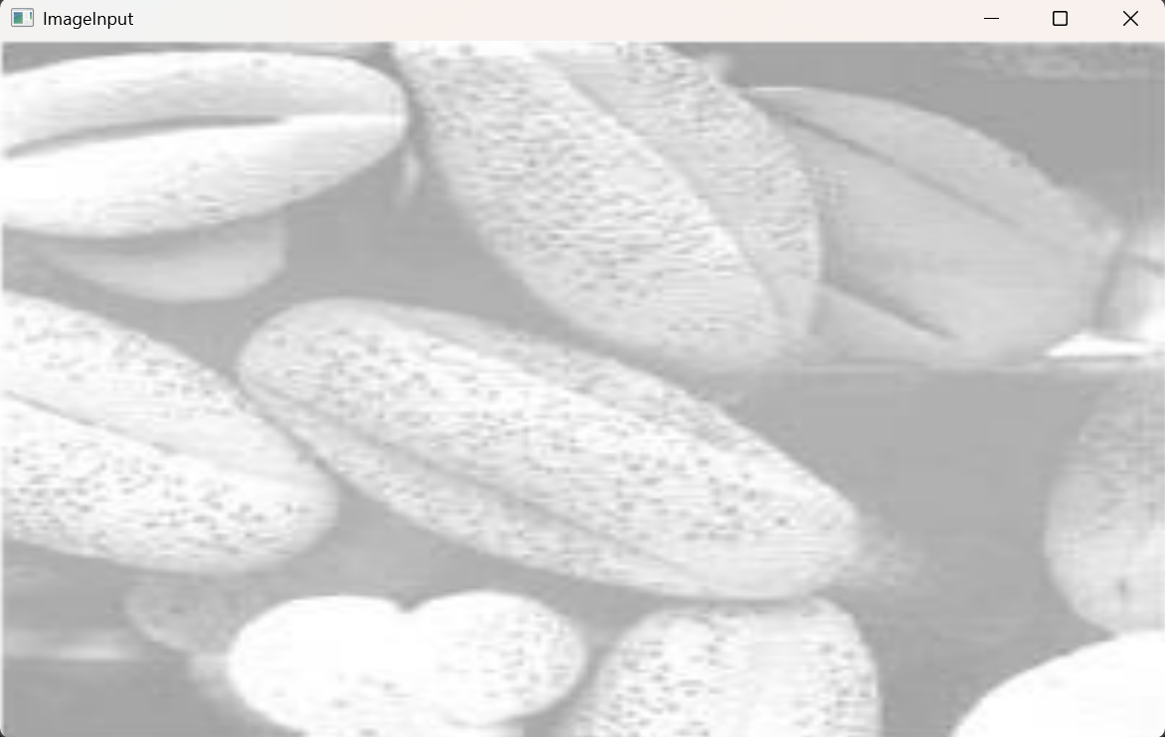 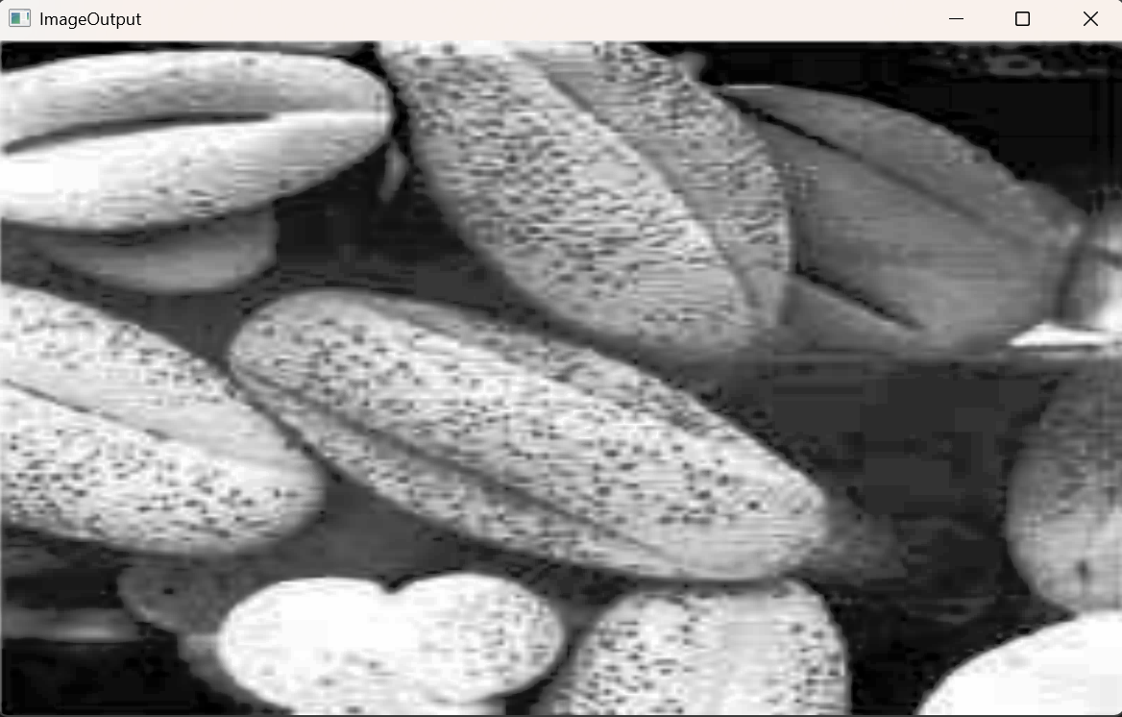

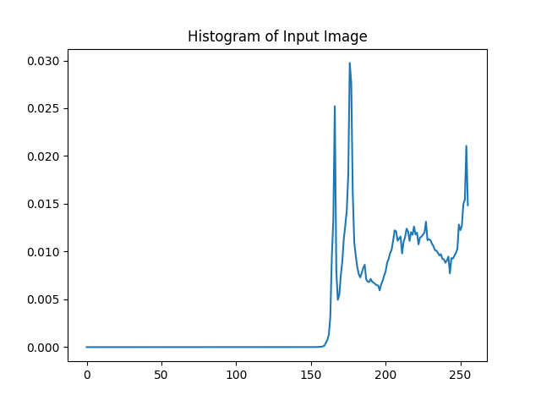 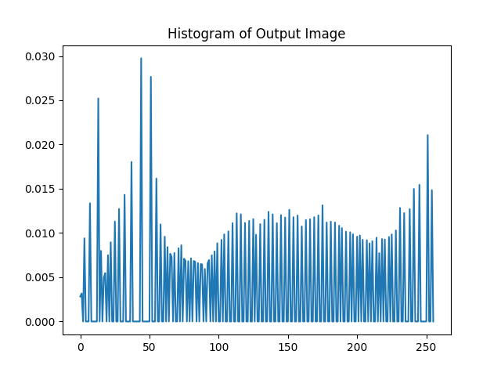

**Input Image: Output Image:**

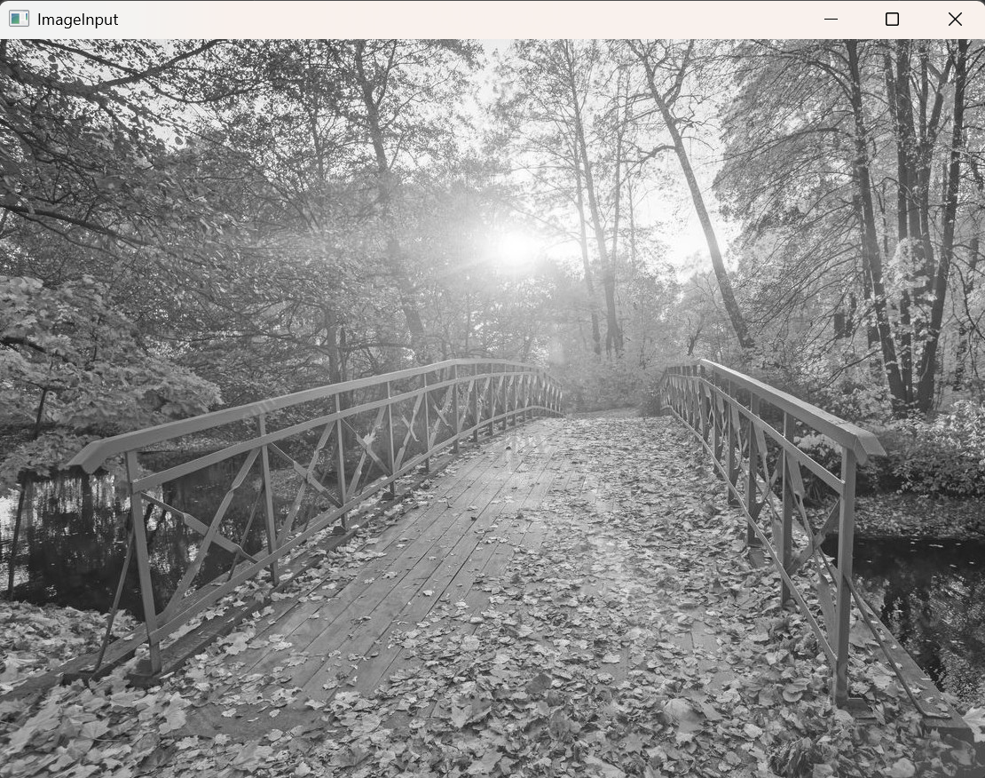 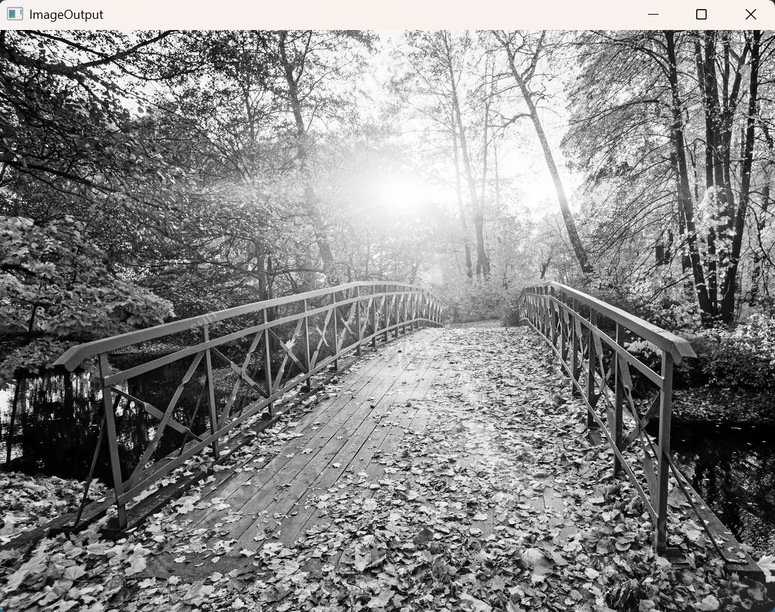

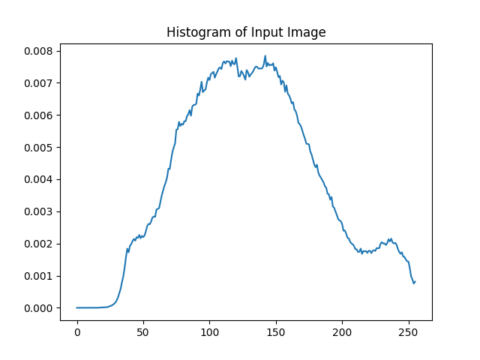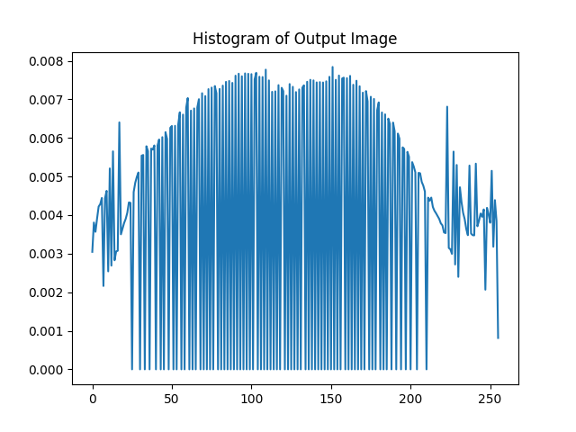

**Input Image: Output Image:** 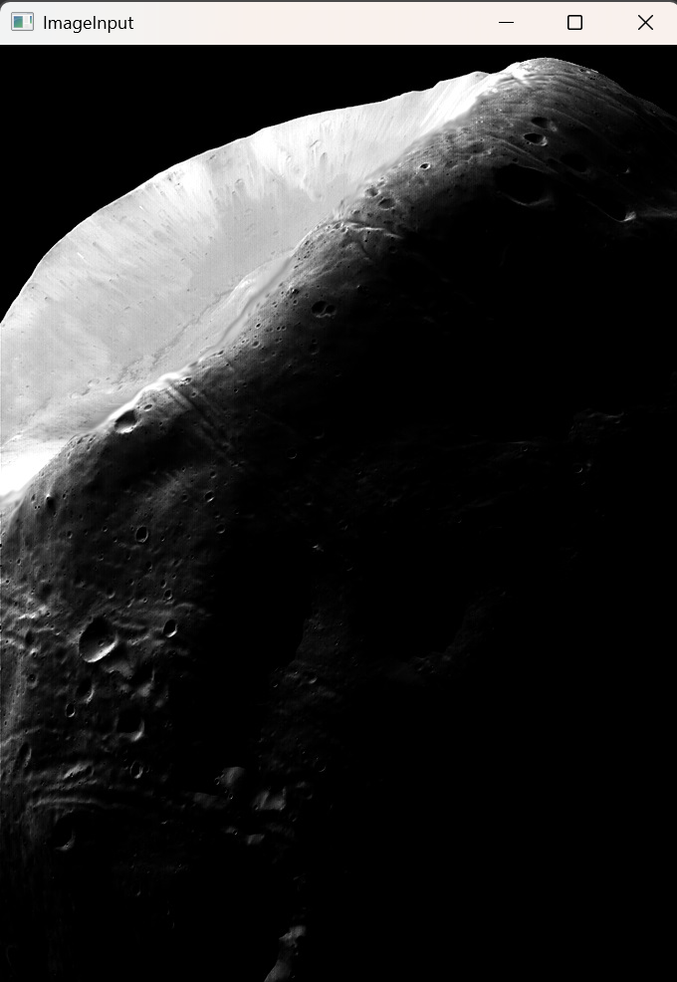 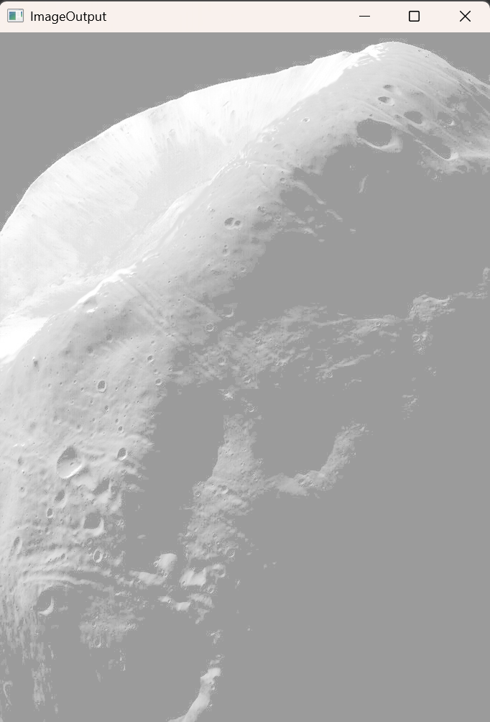

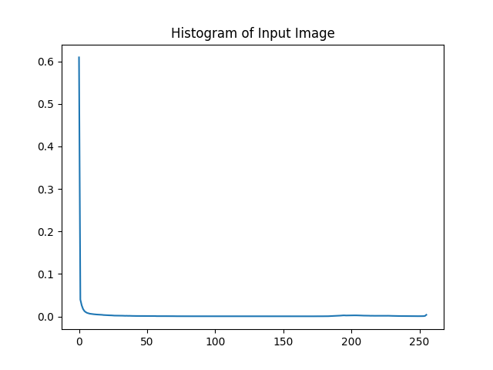 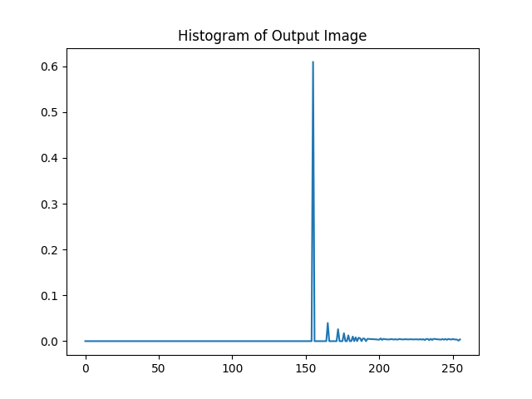

ccsdnfjva

**Conclusion:** The histogram equalization enhances the image by redistributing pixel intensities, improving contrast and dynamic range. In the above images, the histogram of the output gets spread and flattened so the dynamic range and contrast of the image increases. While it improves visibility in most cases, the effectiveness depends on the image type.

In above two images the visual quality increases, but in the case of moon image the visual quality decreases.